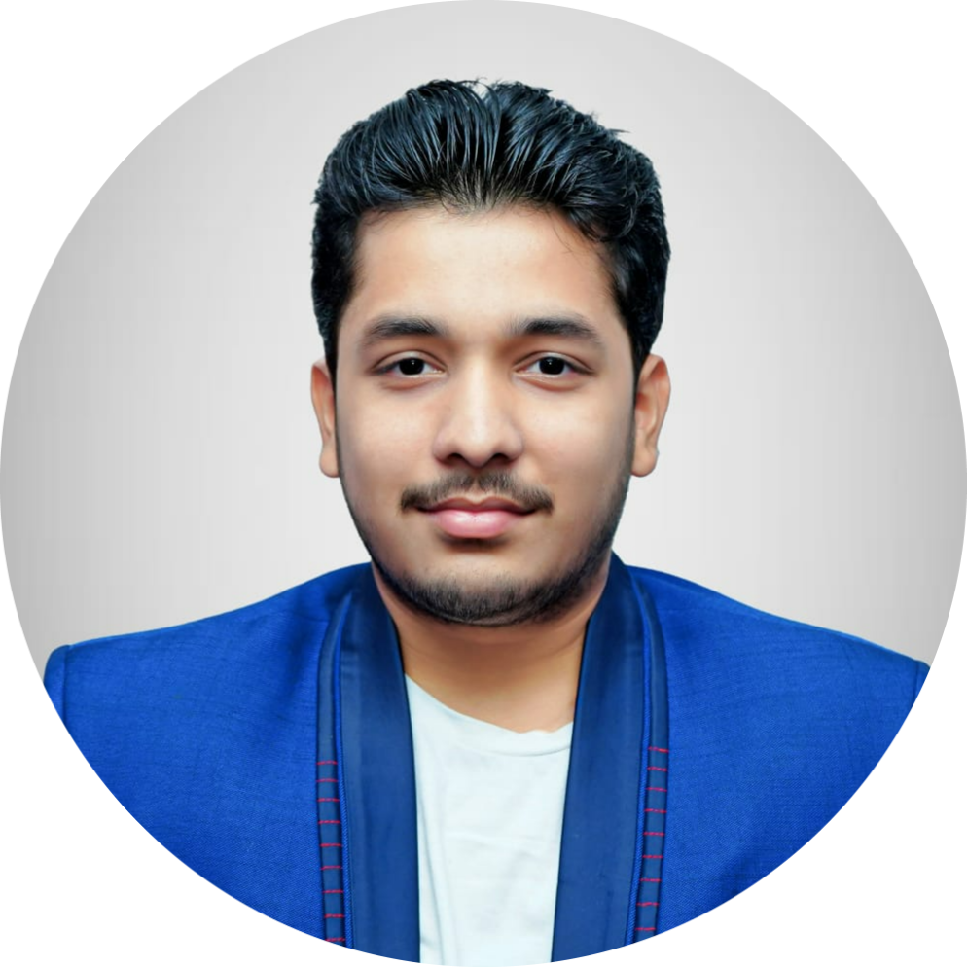**Candidate code: CC102**

<https://github.com/Kowshike>

Vijayawada, Andhra Pradesh

# Career Objective

A proactive and motivated student specializing in cybersecurity and web development. Passionate about coding and driven by innovation, seeking to leverage technical skills in a dynamic industry environment.

# Education

|  |  |  |  |
| --- | --- | --- | --- |
| **Degree** | **Institute** | **Board / University** | **Year** |
| Senior Secondary | Narayana Junior College, Vijayawada | BIEAP | 2019-21 |
| Matriculation | Narayana E.M High School | BSEAP | 2019 |

**INTERNSHIPS**

* **AICTE** *July 2021 - August 2022*

*Virtual Training Intern* Online

* + JUNOS Operating system
  + Network fundamentals
* **Edu Skills Foundation** *August 2022 - July 2023*

*Virtual Training Intern* Online

* + Cloud computing

**PROJECTS**

* **Personal Portfolio** *Dec 2023*

A project that showcases all my projects and work <https://portfolio-kowshik.netlify.app/>

* + Tools & technologies used: HTML, CSS
* **Personal Resume Generator** *Jan 2024 – Jan 2024*

A website designed using React *to generate a resume* <https://kowshik-resume-generator.vercel.app/>

* + Tools & technologies used: HTML, CSS, JavaScript
* **Image Forensics**  *June 2024*

A website designed using Python to analyze the image and provide EXIF data.

* + Tools & technologies used: HTML, CSS, JavaScript, Python
* **Academic Project Management System** *May 2024*

A website designed using Java Full Stack

* + Tools & technologies used: Java Full stack, HTML, CSS, JS, MySQL

# TECHNICAL SKILLS

* **Programming Languages**: C, Java, Python
* **Tools and Frameworks**: HTML & CSS, React.
* **Databases**: MongoDB & MySQL

# CERTIFICATIONS

* **AWS Certified Cloud Practioner** Amazon Web Services
* **Red Hat Certified Enterprise Application Developer** Red Hat Certified System
* **NPTEL Certifications: Demystifying Networks, Ethical Hacking** Swayam
* **Introduction to Cybersecurity** netacad
* **Cybersecurity Essentials** Netacad

# EXTRA-CURRICULAR ACTIVITIES

* **Participated in Learnathon and Hackathon.**
* **Conducted classes for my juniors on fundamental cybersecurity concepts, emphasizing network security, data protection, and ethical hacking at the university.**
* **Pencil Arts and Micro Arts**
* **Social Internship Program at Mursamalli Thanda village.**

# POSITION OF RESPONSIBILITY

* **Aspirant**, White-Hat Hackers Club, at university *Apr. 2022-2023*
* **Technical lead**, White-Hat Hackers Club, at University *Mar. 2023-present*

# ACHIEVEMENTS

* **Miracle-World Record**, Indian National Anthem Carved on a Turdal of size 5mm. *2018*
* Participated in Codekaze 2023 and got a rank of 2106 out of 100K+ participants *2023*